1. Go to <https://azure.microsoft.com/en-us/> and click **FREE ACCOUNT**

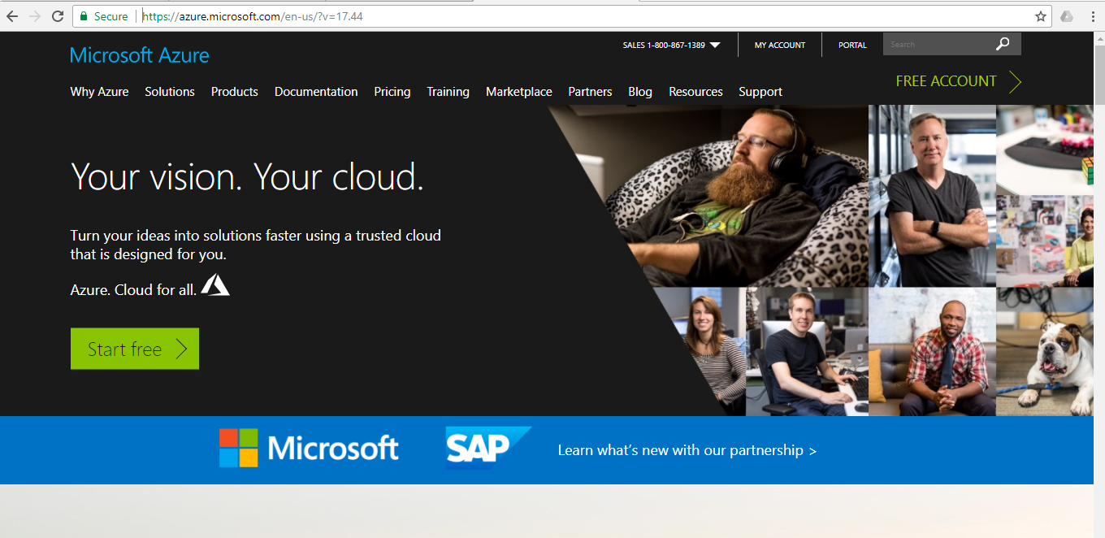

1. Click Start free in the screen below

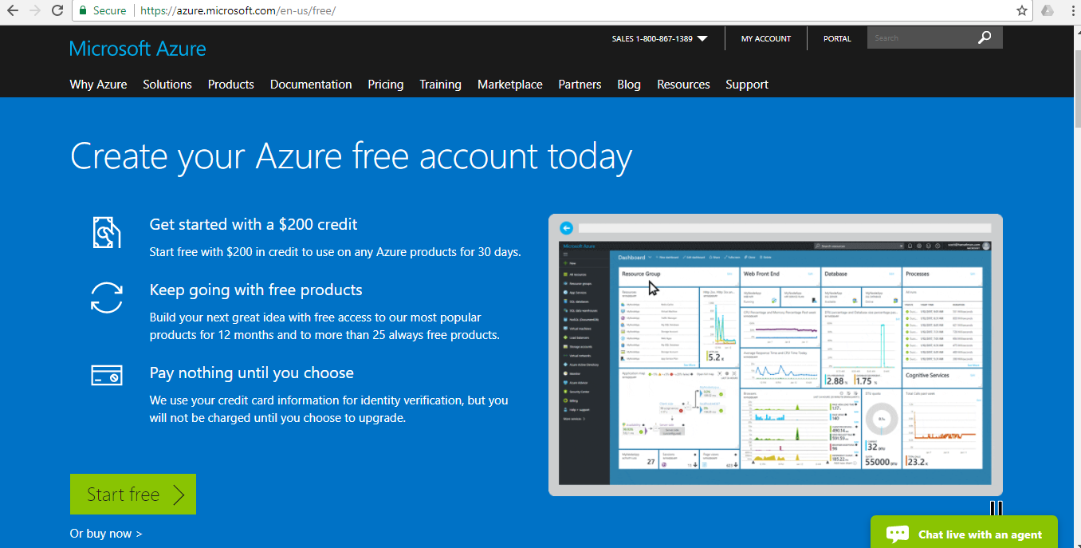

1. Click ‘Sign up’ on the below page

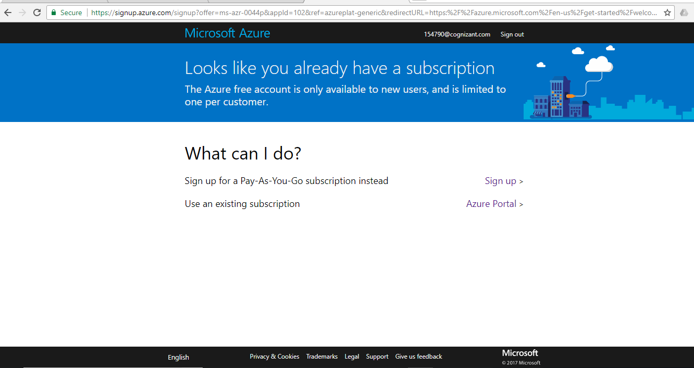

1. Click ‘Create one’ in the below screen

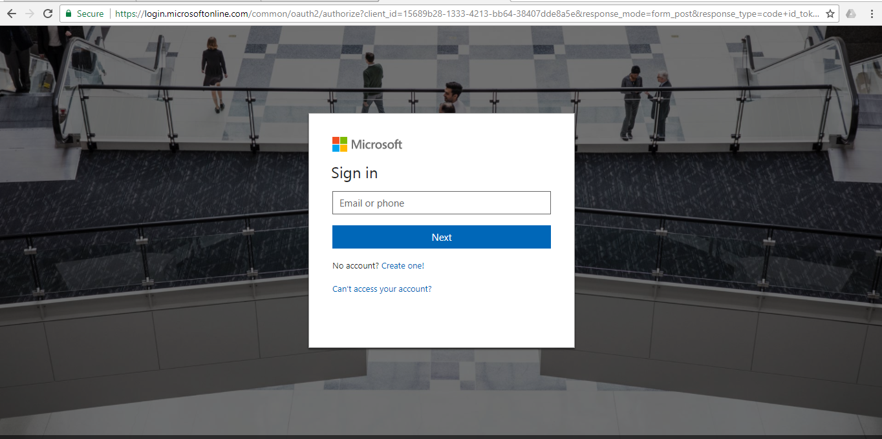

1. Click ‘Get a new email address’ in the below screen

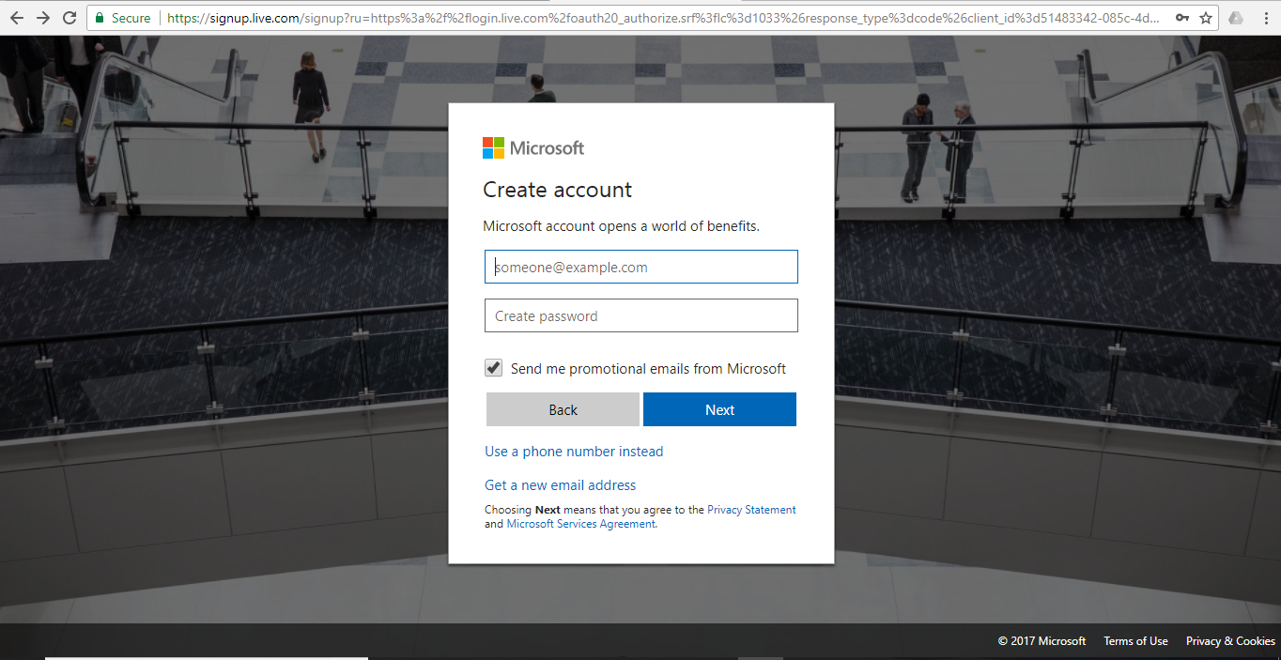

1. Create a valid email id with a password

**Note: Save this email id and password!**

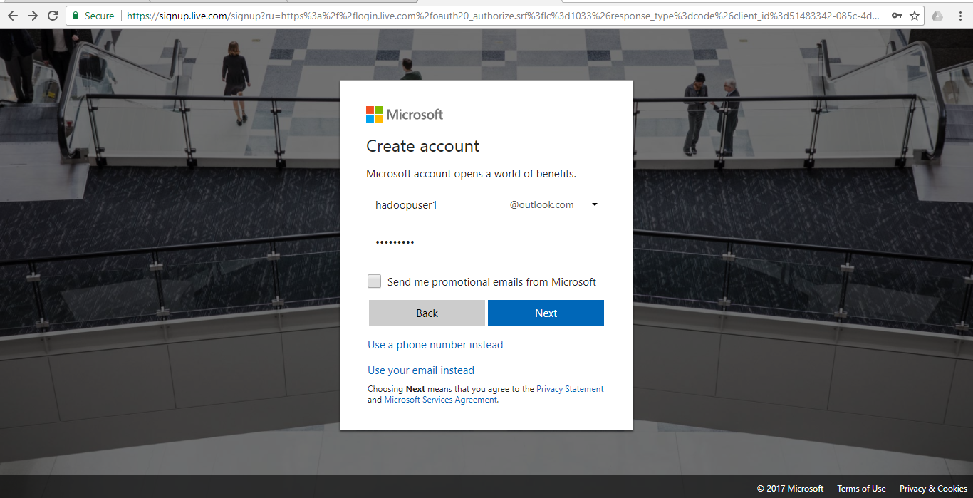

1. Fill up your details and complete the steps in creating a user account 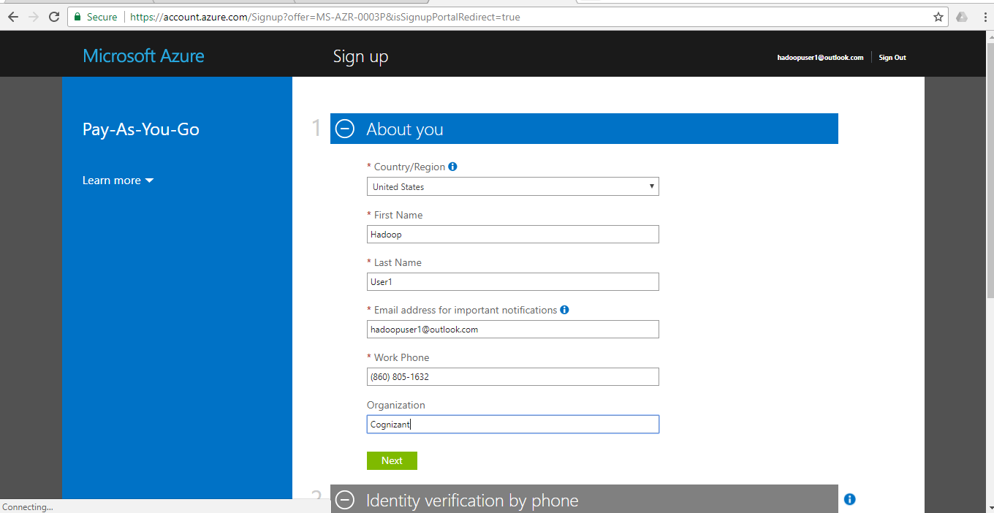

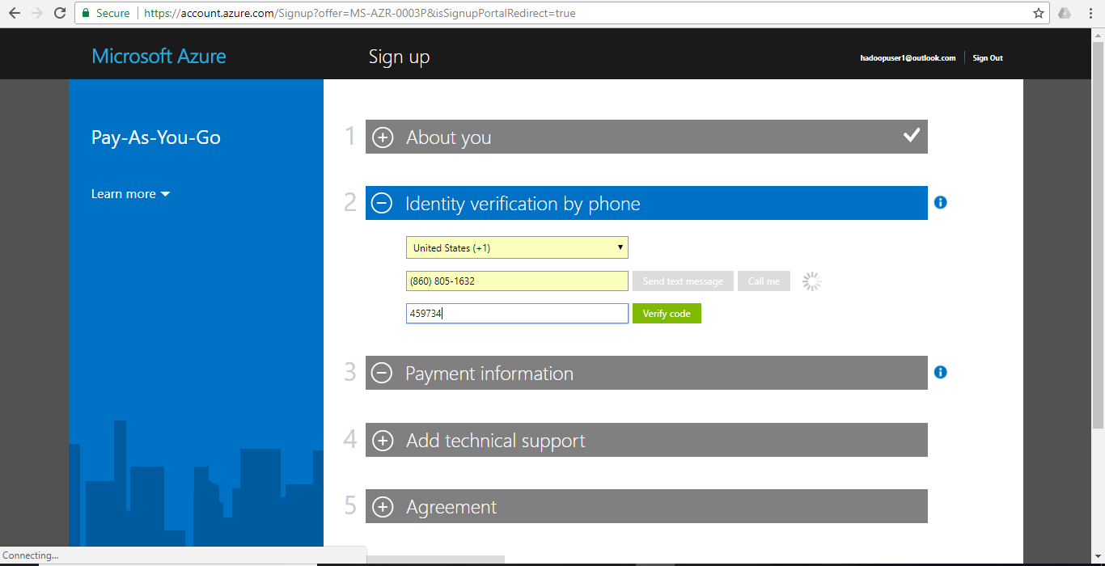

After creating the account go to <https://portal.azure.com> ;

Click ‘Market Place’ in the below screen

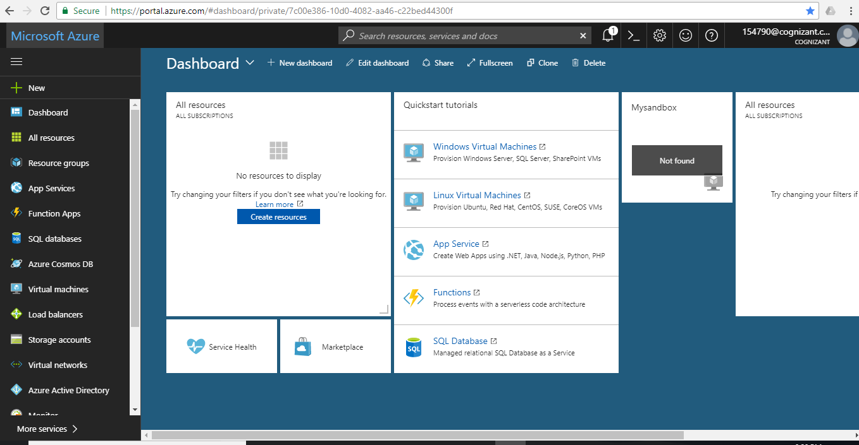

In the below screen type ‘Hortonworks Sandbox with HDP 2.4’ and click ‘Enter’

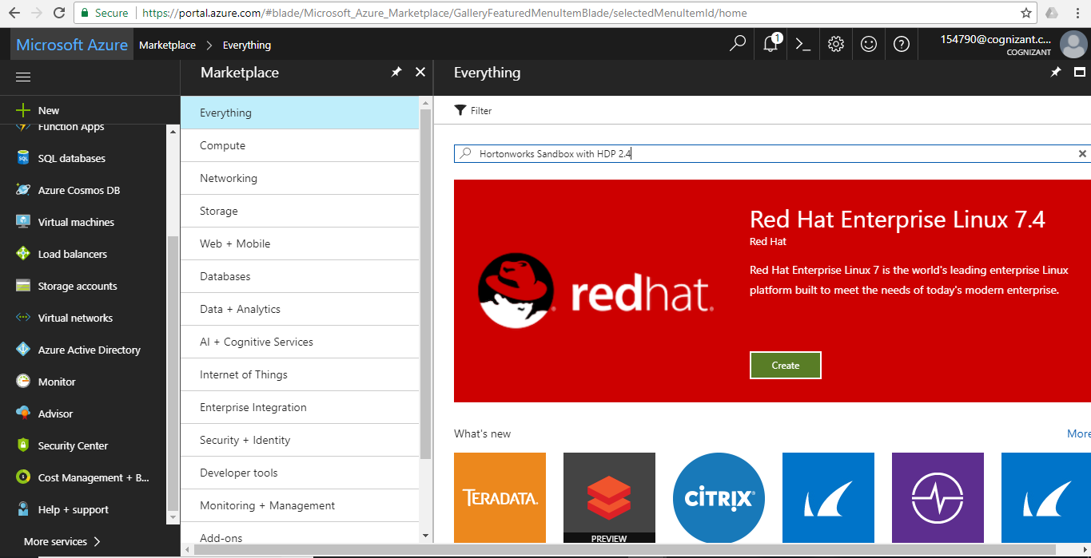

Click on ‘Hortonworks Sandbox with HDP 2.4’ as shown below

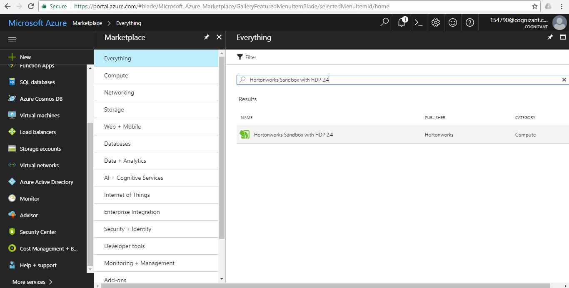

Click on ‘Create’ in the below screen

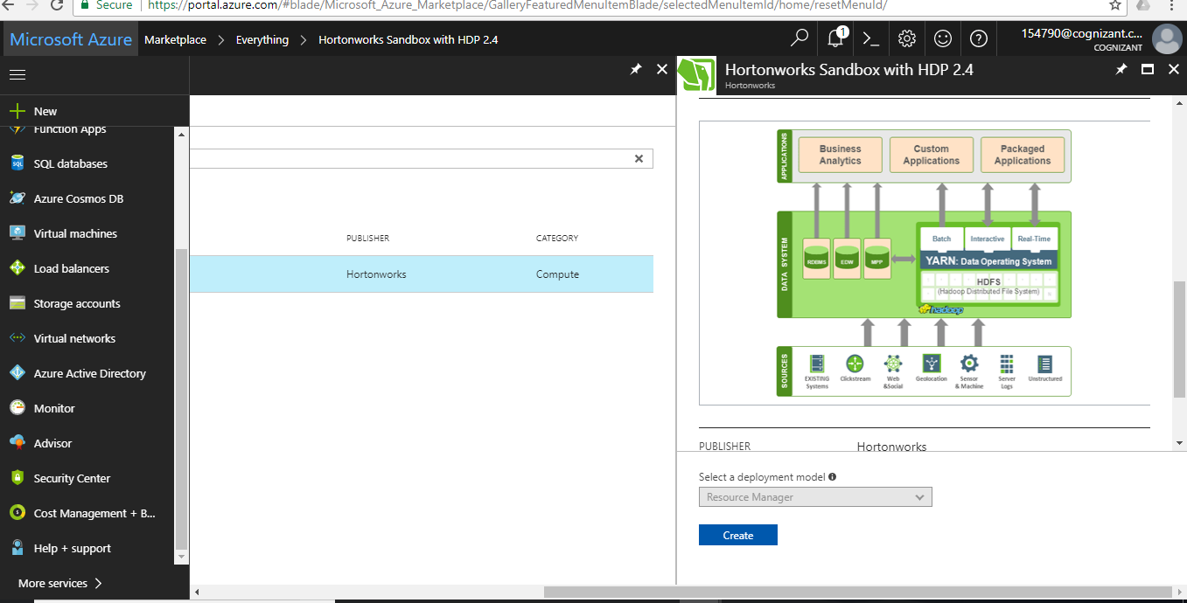

Next -> Configure the basic settings

Note: Subscription will be shown as ‘Free-Trial’ for the first time user

/!\ Also make a note of all the basic configuration details

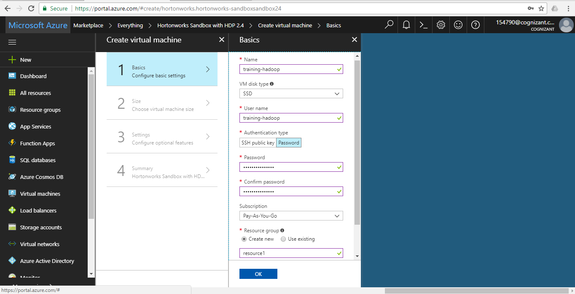

Select the sizing of the cluster -> Choose ‘A5 Standard’ and click ‘Select’ in the below screen

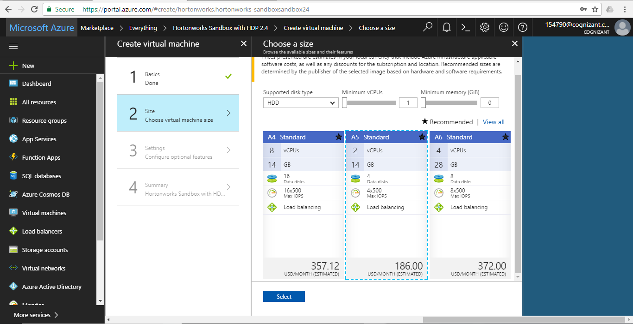

Click ‘Ok’ in the settings tab (to follow the default settings)

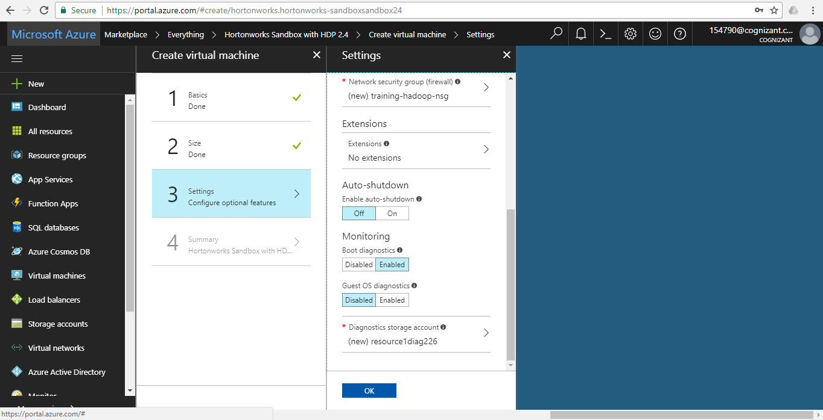

Click ‘Create’ in the below screen to set up the sandbox

Note: 0.25 USD/hour will not be charged to your credit card as Azure is providing $200 credit for ‘Free-Trial’ for first 30 days. After that its Pay-As-You-Use which is 0.25USD/hour

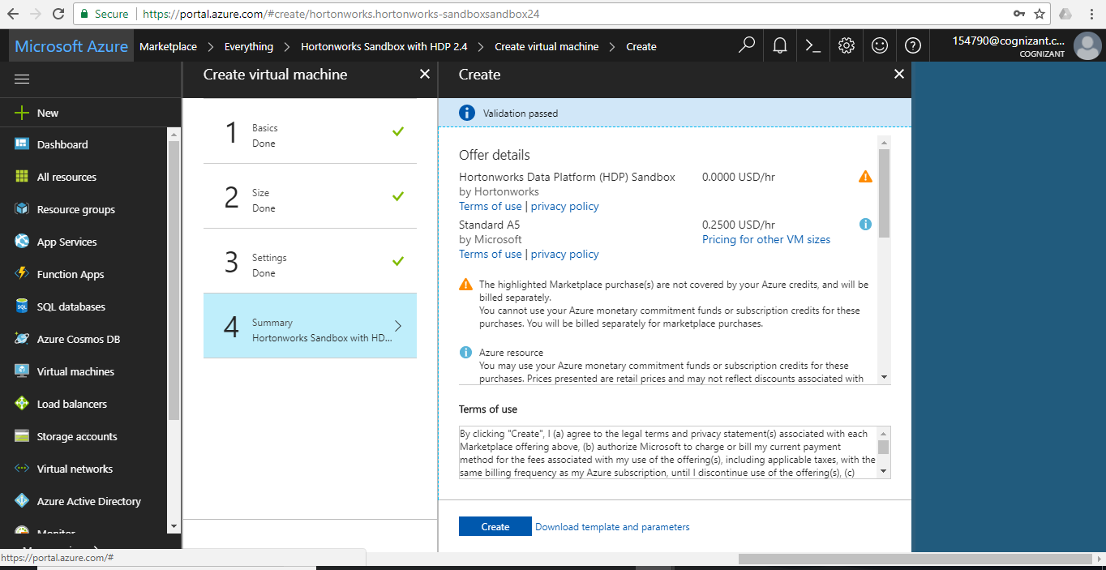

Deployment of the sandbox on the cluster is in progress

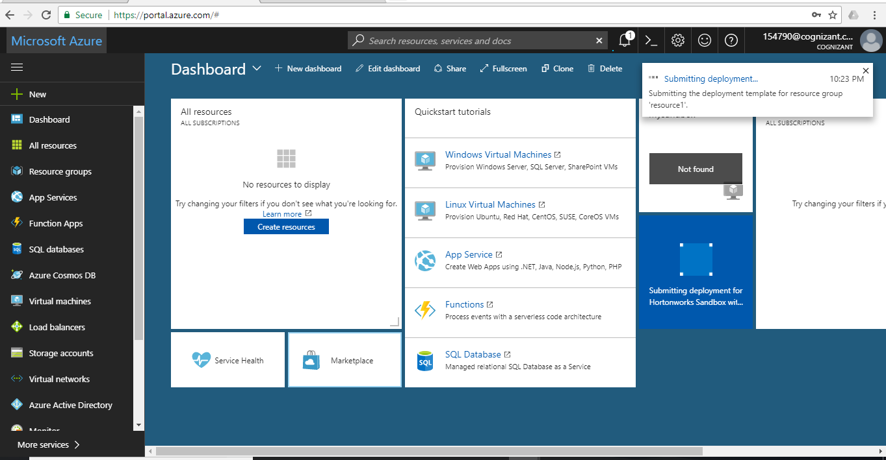

After the deployment is completed you will see the message as ‘Deployment succeeded’ and the VM (training-hadoop) opens up as shown below

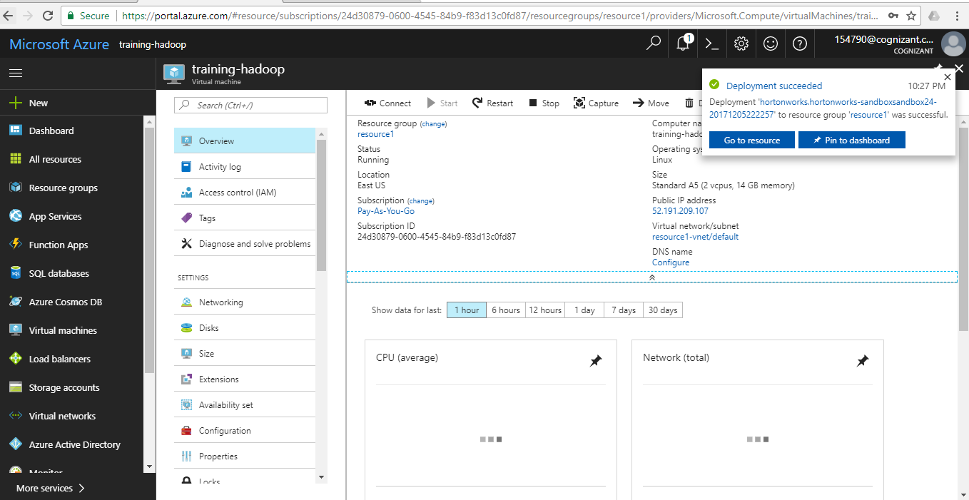

Details of the VM

Click ‘Virtual Machines’ on the left Navigation bar as shown below

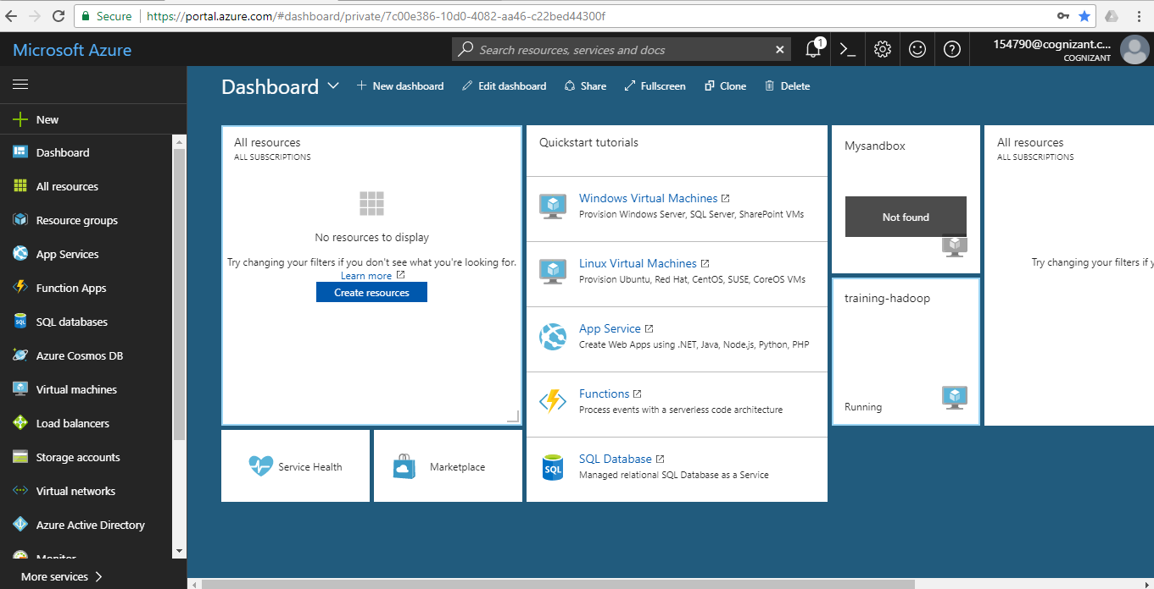

Click ‘training-hadoop’ (the VM created during the basic config steps)

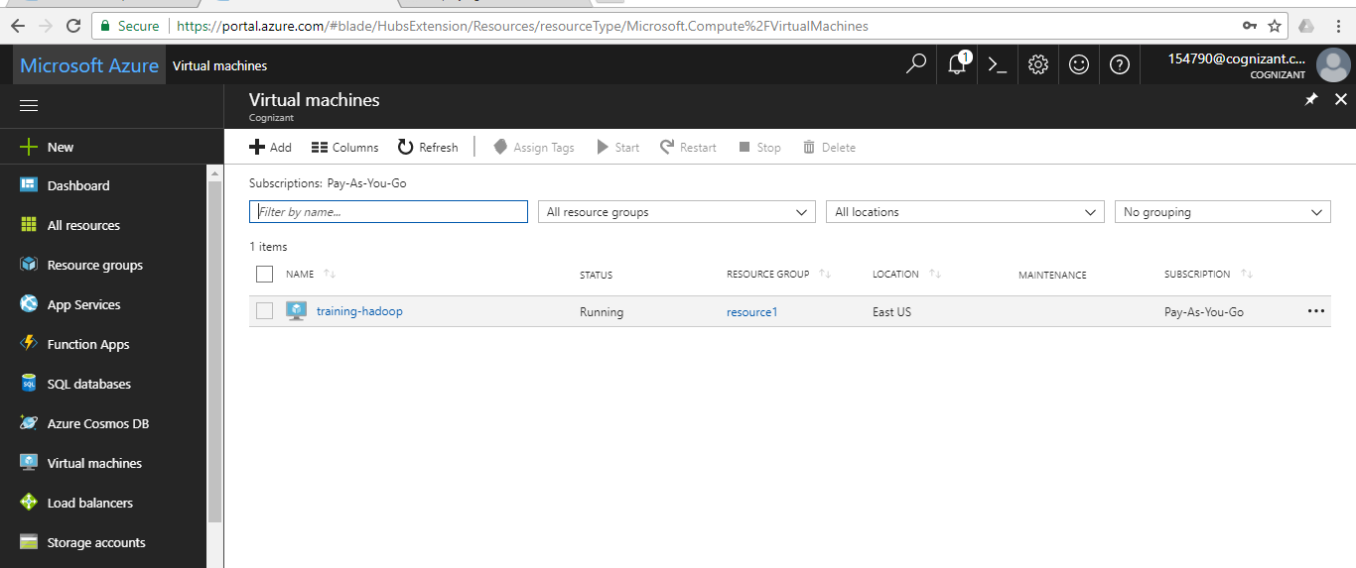

Details of the VM

Note the IP address of this virtual machine 52.191.209.107 and click it

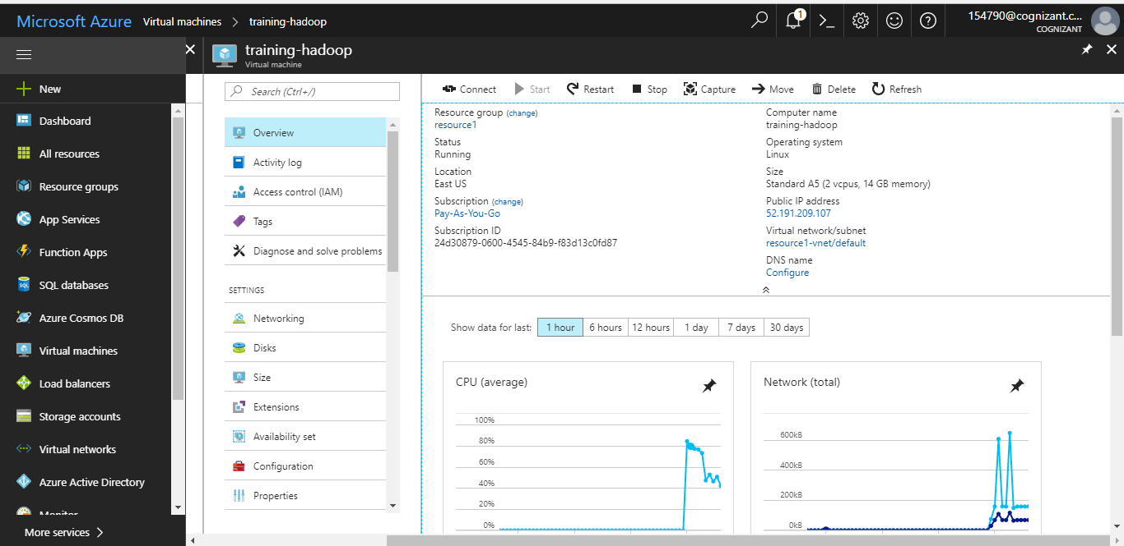

Click ‘Static’ in the below screen and save the changes

Note: This is being done so that the public IP address doesn’t change each time the VM is booted

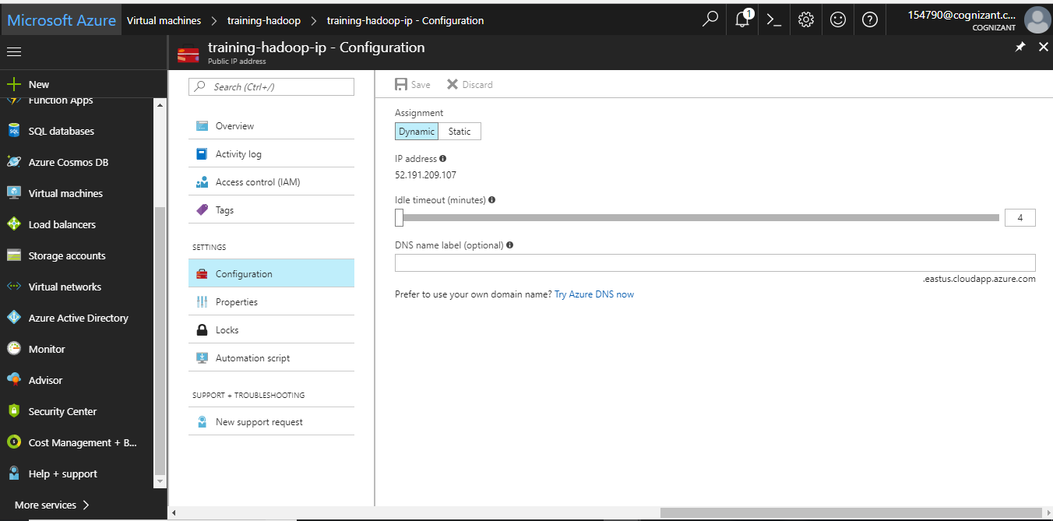

Use the above given IP address of the VM to connect to the sandbox.

Registration IP: 52.191.209.107:8888

Ambari: 52.191.209.107:8080

If you are not able to connect above given registration page perform the below changes in the VM

Click ‘Resource Group’ in the below screen

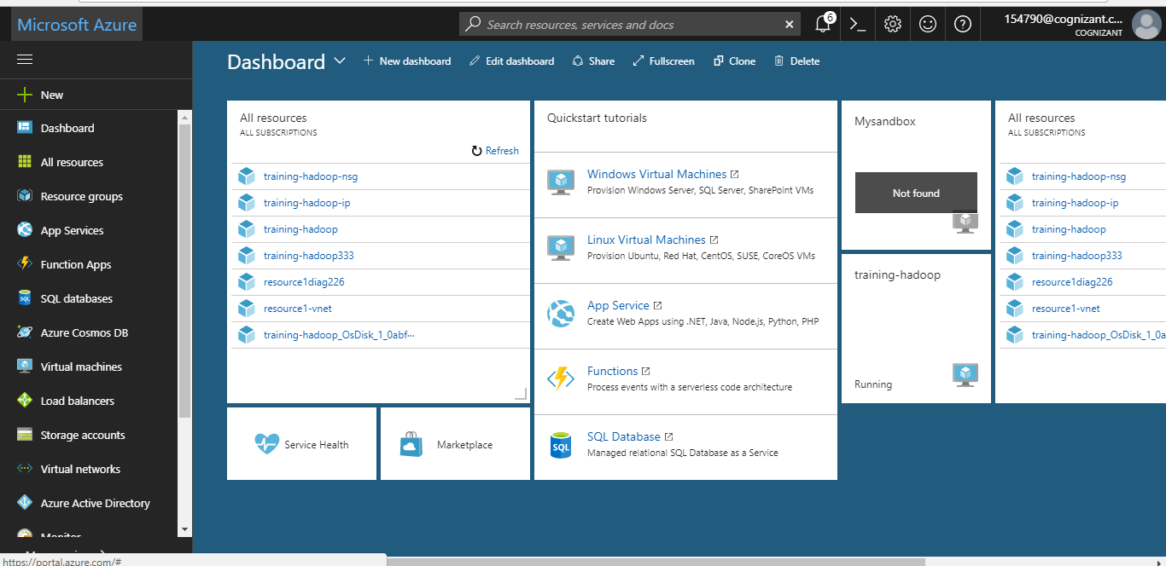

Click ‘resource1’ as shown in the below screen (this is the resource we created while setting up the VM)

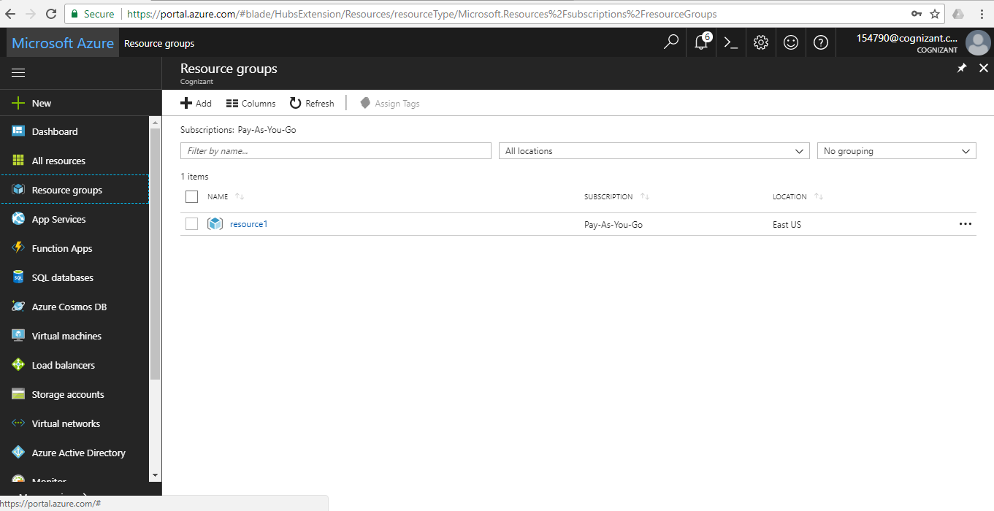

Click training-hadoop-nsg in the below screen as shown

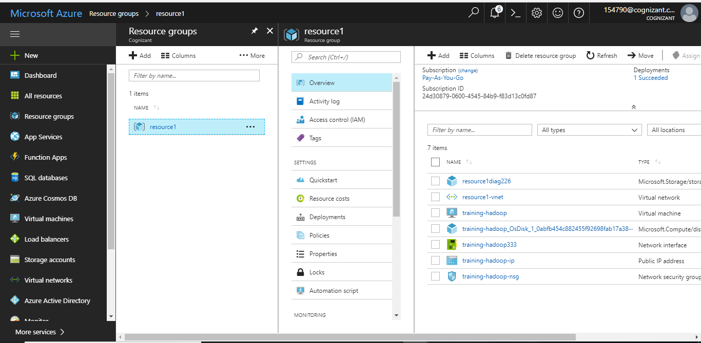

Click ‘Inbound Security rules’ in the next screen

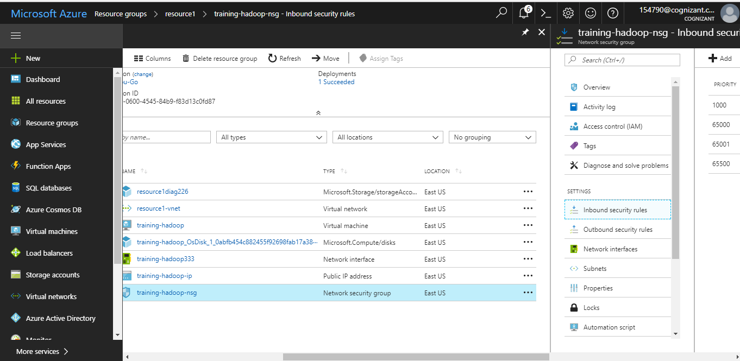

Click ‘Add’ in the next screen

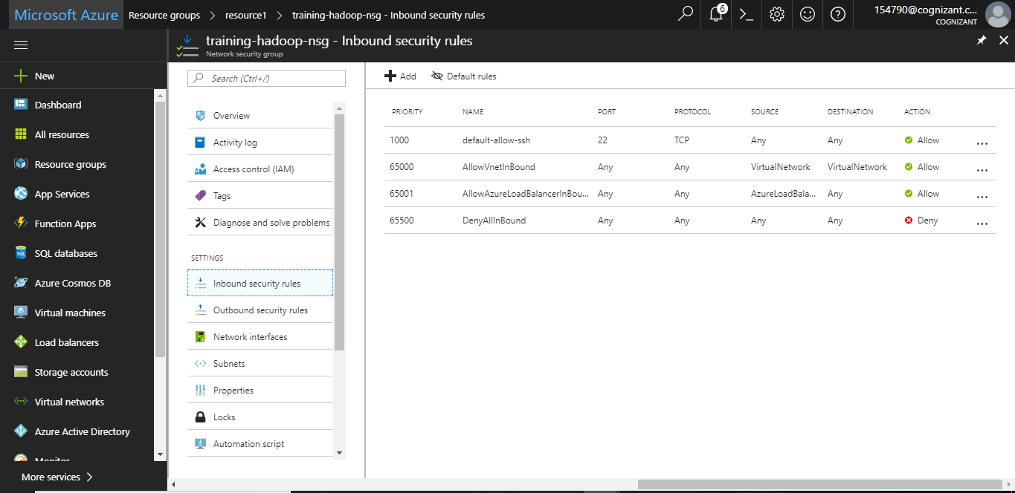

Fill up the details as shown below and click ‘OK’

Note: Now we have opened the firewall to connect to the port 8888 on this VM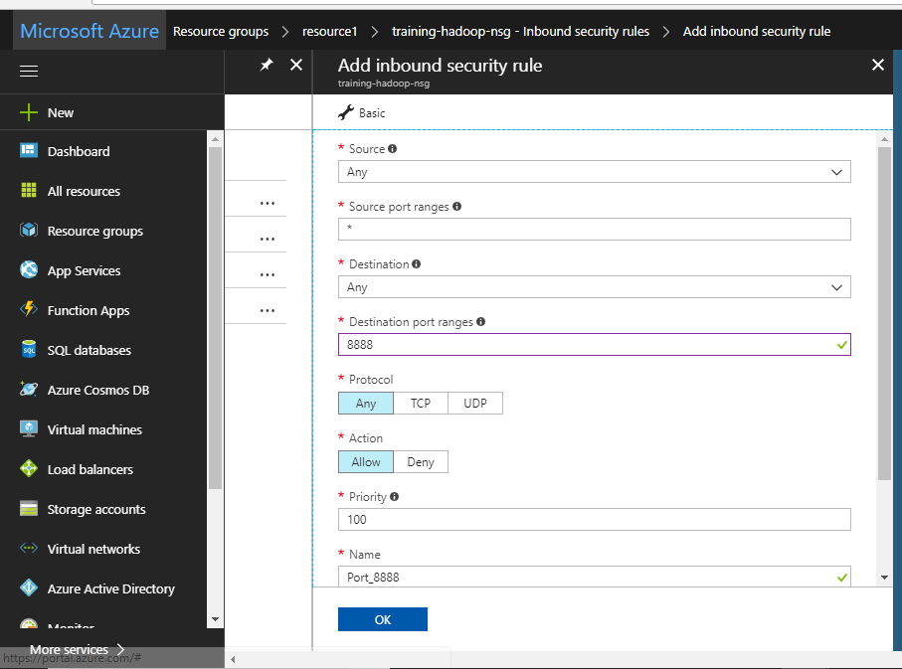

Same as above step, open the firewall for the port 8080 as shown below

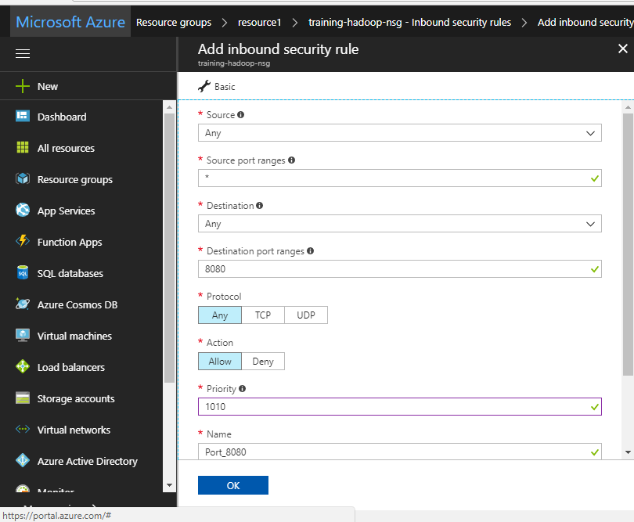

New Inbound security rules are added to the VM as shown below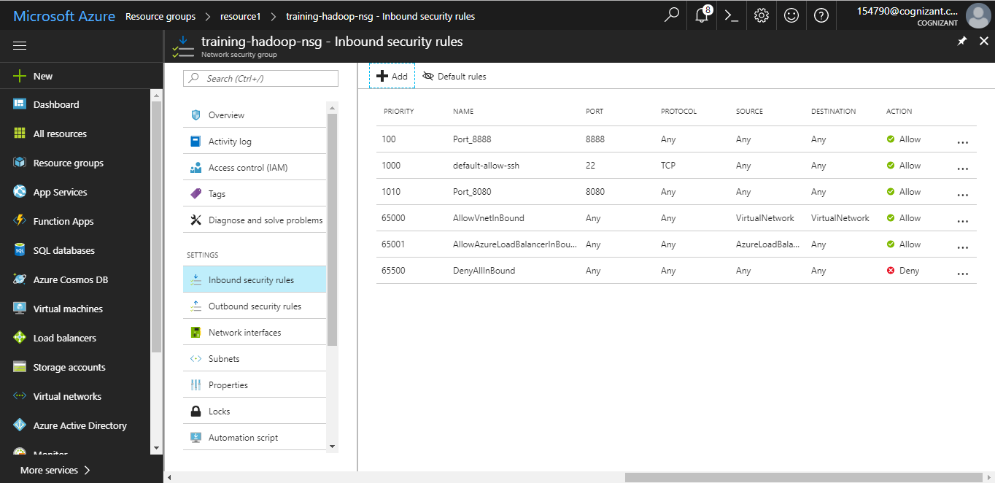

Go to a browser and enter <http://52.191.209.107:8888> to connect to the above VM and fill up the details as shown below

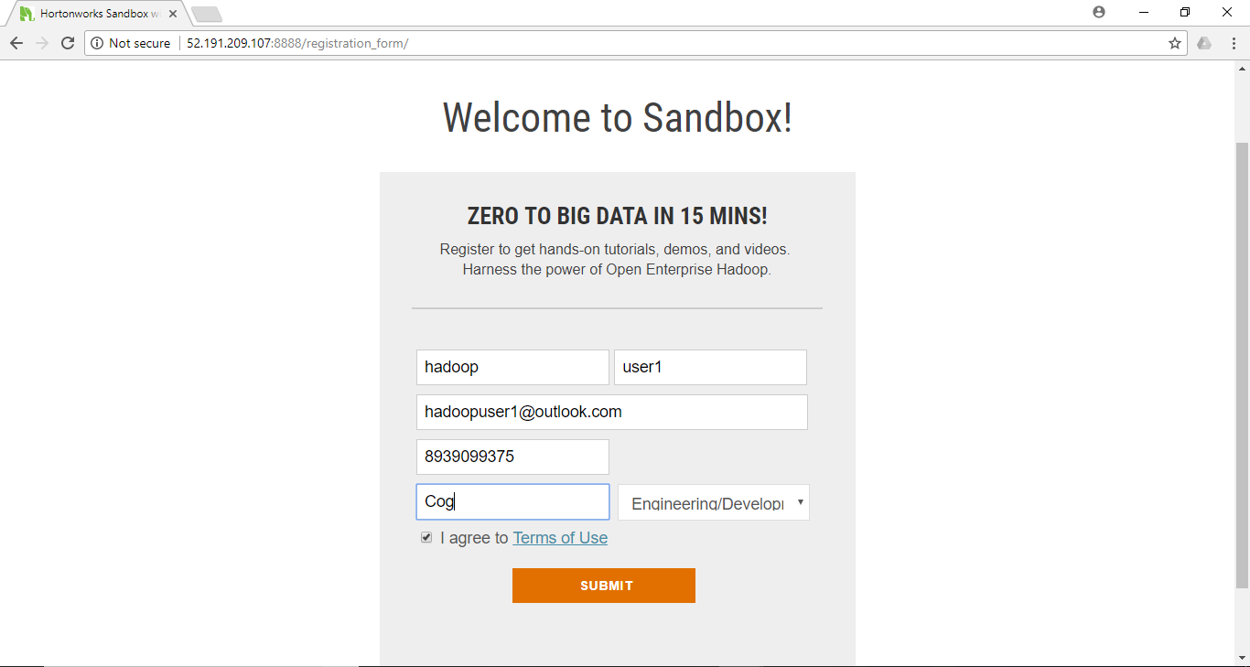

Click ‘LAUNCH DASHBOARD’ in the screen below

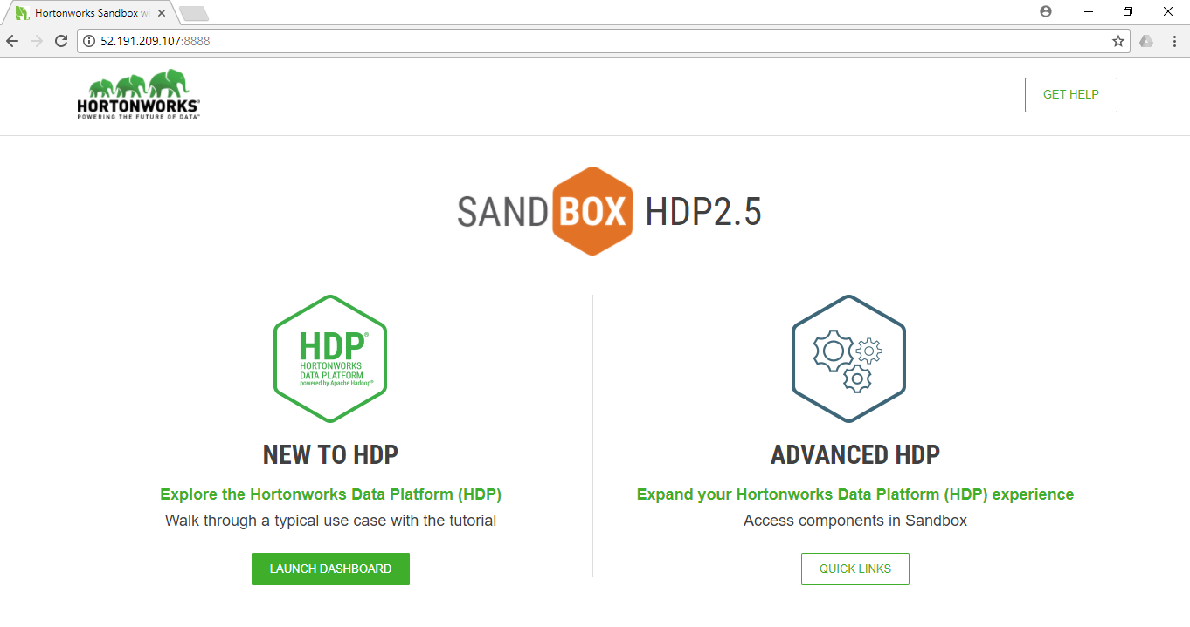

Enter ‘raj_ops as both userid and password in the screen below

Note: Disable the pop-up blocker in your web browser

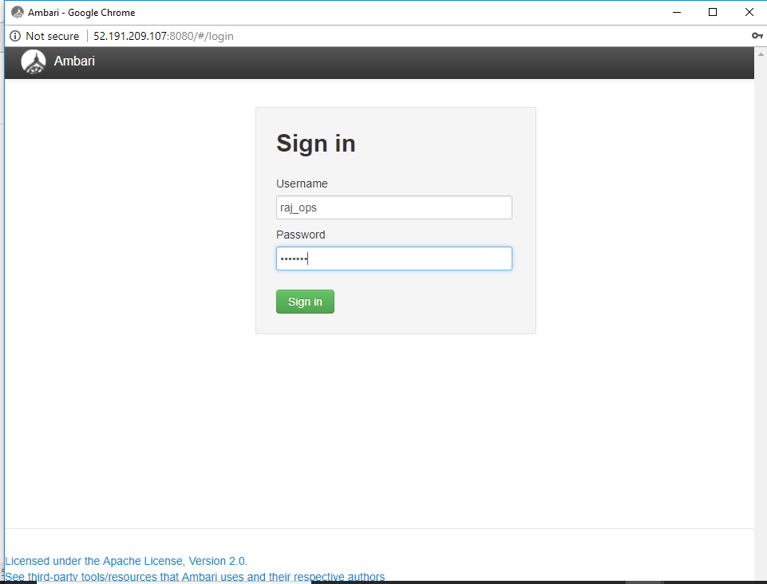

You have successfully logged into Ambari

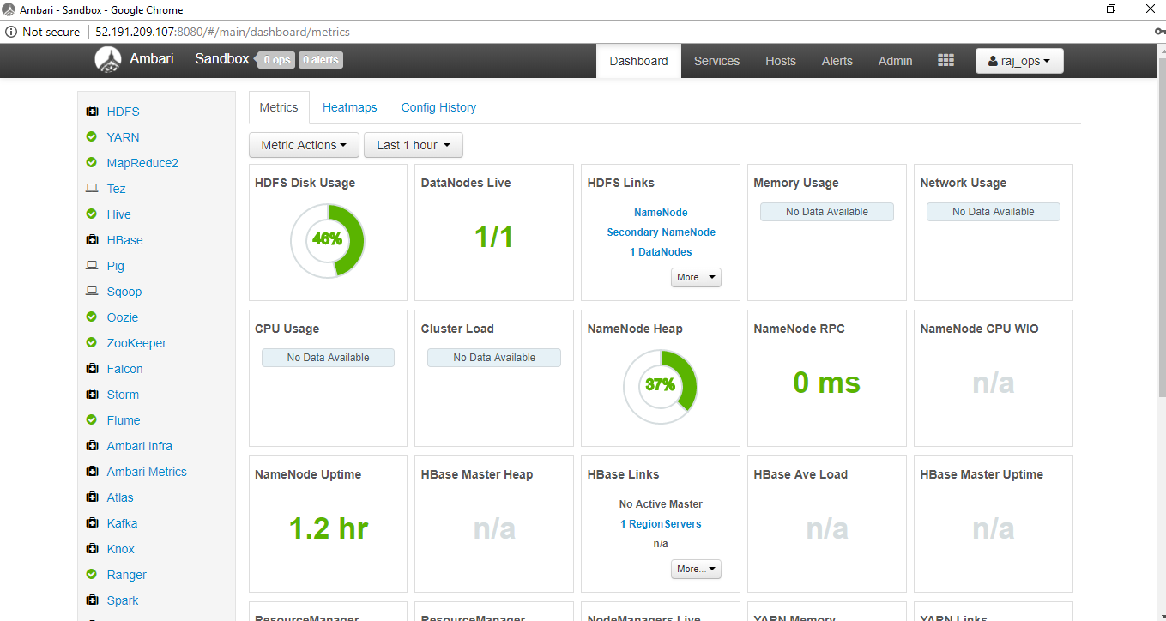

After finishing up all the work in the VM go to ‘Virtual Machines’->’training-hadoop’->Overview-> ‘STOP’

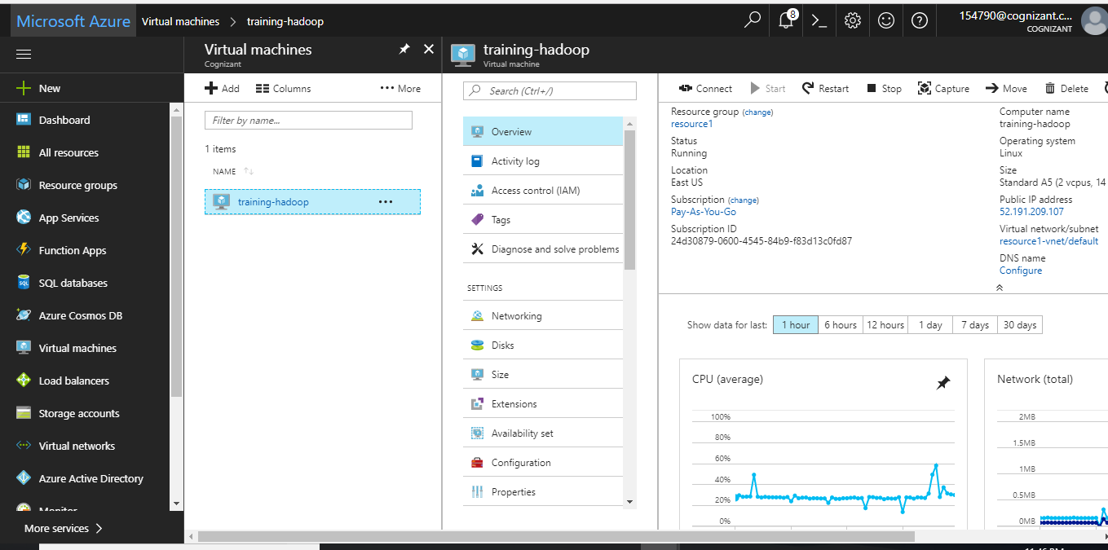

Click ‘Yes’ to shut down the VM

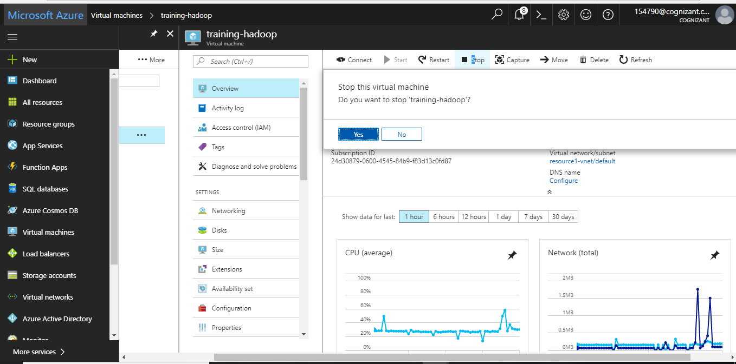

How to connect to putty

Use the IP address generated above to connect to putty

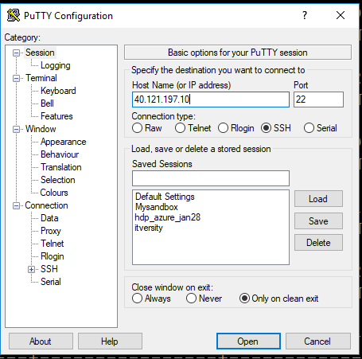

Use the user-id ‘training-user and password ‘Training_hadoop’ to log into putty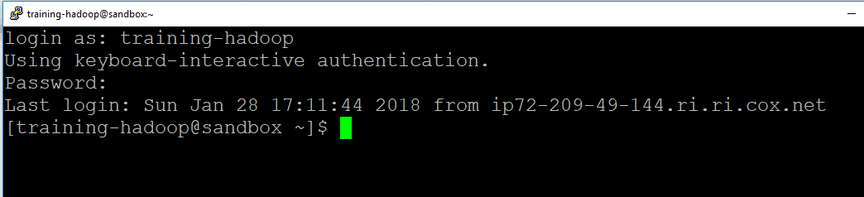

Change the user to ‘root’ using the below command

ssh -p 2222 root@localhost



Change the default root user’s password (**hadoop**) and create a new one (**Save this new password**).

After that you will be able to log in to the cluster

